Checks to make before uploading csv file (MPP) to i-Connect
There are several checks you must make before uploading your csv file, which will prevent issues with the file failing to upload and reduce errors or queries after the file has been uploaded.
1. Check the numbers on your file look reasonable
2. Checking for commas
3. Filtering the columns to check the data is correct
4. Checking for blank lines of data
5. Ensuring the file is saved as a csv

- Check the numbers on your file look reasonable

Have a look at the numbers on your file to make sure that they seem reasonable compared to previous months. If they are higher or lower than expected, is there a reason, for example there is an increase in leavers due to a redundancy exercise.

- Check for any commas in the file
First of all, check if there are any commas in the data. If there are, the data will be misaligned, so the file may not upload, or the data after this will be in the wrong columns. This is because the comma will signify a new column in the csv file (csv standards for column separated value).
Press the ‘Ctrl’ & ‘F’ keys together, which will bring up the ‘Find and Replace’ box.
Insert the comma character (,) in the ‘Find what’ section and ‘Find Next’.
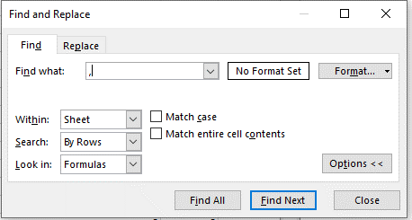
This will bring up any commas in your file, which must be removed.

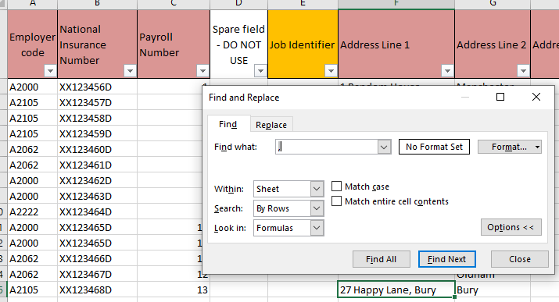

In the example below, there’s a comma in the address, so the comma needs to be removed from the file.
The address in your payroll system will also need to be amended, otherwise this will keep appearing on future files.
- Filter the columns to check the data is correct
Apply filters to the file to check the data in each column is correct & cross-reference with other columns, as necessary
If you don’t know how to do this, select the ‘Data’ tab
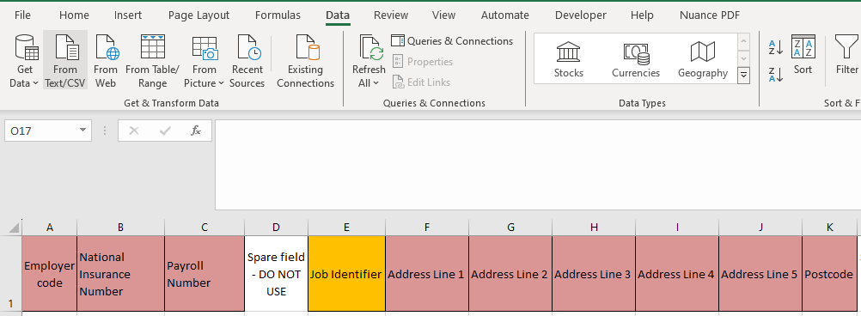
Highlight the header row and then select ‘Filter’

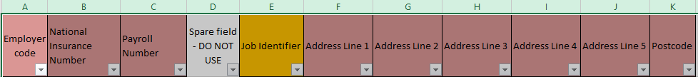
This will then allow you to filter the data in any of the columns by clicking on the down arrows individually.

You need to check the following columns:-
- Those highlighted in red are vitally important checks
- Those highlighted in green are essential for new starters
A – Employer code
- Is there an employer number for everyone?
- If not, you need to add the correct employer number.
- There may be lines at the bottom without data, which would show as ‘blank’, so you need to delete these lines.
B – National Insurance number
- Is there a National Insurance number for everyone?
- Are these in the correct format?
- Are there any ‘TN’ (temporary) numbers? Ideally you should only add members onto your file when you know the correct National Insurance number.
C - Payroll Number
- This is an essential field for every line.
- Is there a Payroll number for everyone on the file?
- Are these in the correct format?
- If you use leading zeros in your payroll numbers, have these been applied?
D – Spare Field (do not use)
- You need to make sure this column is blank

E – Job Identifier
- This is only required if any members have multiple posts and the payroll number is the same for each post. If this isn’t the case, just leave this blank.
- If you need to use this, is there a job identifier for everyone?
- Are these in the correct format?
- If you use leading zeros in your payroll numbers, have these been applied?
F – Address Line 1
- Is there a first line of the address for everyone?
- If not, you need to add this.
G – Address Line 2
- Is there a second line of the address for everyone?
- If not, you need to add this.
H to J – Address Line 3 to 5
- These aren’t always required.
- Columns F & G are essential, but columns H to J are only needed if there’s a longer address.
K – Postcode
- Is there a postcode for everyone?
- Are these in the correct format, with ONE space between the 1st & 2nd parts of the postcode? See how to check that postcodes are in the correct format.
- Make sure a zero is not a letter ‘O’ and a letter ‘O’ is not a zero.
L – Spare field – DO NOT USE
- You need to make sure this column is blank
M to V – Telephone Number, Mobile Number, Work address & Work email address
- These aren’t required, but you can input data if you wish
W – Date of Leaving
- If a member has left, retired or opted out with more than 3 months membership), you need to make sure the date has been entered here
- If a date of leaving or retiring (or date opted out if more than 3 months membership) has been entered, have you also provided a reason for leaving in column BF?
- If a member left, retired or opted out in a previous year, these should be removed from your file.
X – Payroll Period End Date
- This date should be the same for everyone on the file, being the end date of the latest month / pay period
- Even if a member left before the end of the month, the date should still be the end of the month / pay period
Y and Z – AVCs, ARCs and Added Years contributions
- Data is only required if the member make additional payments for Additional Voluntary Contributions, Additional Regular Contributions or Added Years contributions
- You need to provide the cumulative figure in these columns
AA - Break in service start date
- If a member has a service break (including unpaid additional child related leave), have you provided the start date?
AB - Break in service end date
- If a member has returned from a service break (including unpaid additional child related leave), have you provided the date they returned?
AC - Spare field - DO NOT USE
- This needs to be left blank
AD - Break in service indicator
- If there’s a date in column AA, have you provided an indicator to show the reason for the service break?
AE - Surname
- Have you provided a surname for everyone?
AF - Forename(s)
- Have you provided a forename(s) for everyone?
AG - Gender
- Have you provided a gender for everyone?
- This must be either M or F.
- If you input male or female, you won’t be able to upload the file

AH - Date of Birth
- Have you provided a date of birth for everyone?
- Is this in the correct format of dd/mm/yyyy? (This must be in the English UK format, not the English US format of mm/dd/yyyy)
- Please ensure nobody aged over 75 is on your file, as members are not allowed to be in the LGPS after age 75.
AI - Marital Status
- This isn’t required.
- If used, you must use the standard indicators as shown on the specification.
  - C - Civil Partnership
  - D - Divorced
  - M - Married
  - P - Declared Partnership
  - S - Single
  - W - Widowed
  - If marital status is unknown please set to S
AJ - Title
- This is required for every member
- You need to use one of the standard indicators as shown on the specification
AK - Spare field - DO NOT USE
- This needs to be left blank
AL - Taxable earnings
- This is only needed for new starters.
- You should just input ) or 0.00 for any new starters
AM - Pay on joining the fund - Full time equivalent
- This is only needed for new starters.
- If entered, you need to input the full-time equivalent pay for the post at the date of joining.
AN - Pay period CARE Pay
- There should be a figure in this column for every member.
- The figure should only be 0.00 if the member:-
- Works casual hours & hasn’t worked in the month
- Is on a service break
- Has opted out with less than 3 months membership
- Left in a previous month or pay period
- Is on unpaid additional child related leave
- After filtering to find any members in categories 1-5 above, there should be no members on your file who are showing as no pay this month or pay period.
- If there are any remaining members with no pay in the current pay period, you will need to investigate why, as there should be some pensionable pay recorded for these
  - If the member is on unpaid additional maternity leave, you should record them as being on a service break (in column AA)
  - If the member is on zero pay due to sickness, you should provide the Assumed Pensionable Pay (APP) figure for the month
- There can be a negative value if an overpayment of pay is being recovered
- If there is a negative value, there should be data in the relevant columns to explain this (for example date of leaving from a previous month, opt-out date entered, reduction in hours shown in a previous month)
AO - Effective date
- This is only needed for new starters.
- For any new starters, you need to provide the date the member joined the pension scheme.
- The date entered should also be entered in AP (same date - for new starters ONLY).
AP - Date joined pension fund
- This is only needed for new starters.
- For any new starters, you need to provide the date the member joined the pension scheme.
- The date entered should also be entered in AO (same date - for new starters ONLY).
- When you filter on this column do the number of new starters seem reasonable?
AQ - Job title
- This isn’t required, but you can provide this if you wish.
AR - Change of hours Effective Date
- This is essential for any members who work part-time or casual hours
- If a member has recently changed from part-time to full-time hours, you must also provide the date of the hours change here.
AS – Hours
- This is essential for any members who work part-time - you need to provide the hours they work each week
- For term-time only members, the hours are those worked during term-time only
- Please leave this blank for any members who work full-time or casual hours
- When you filter on this column and if the member is part-time, there should always be a ‘Y’ in column AT.
AT - Part-Time Indicator
- This is required for members who work part-time or casual hours
- If part-time, enter Y
- If casual, enter C
- If the member works full-time, leave blank
- When you filter on this column and if there is a ‘Y’ then hours should be recorded in column AS.

AU - Whole-Time Equivalent Hours
- This is essential for any members who work part-time - you need to provide the standard hours for the post (the hours if the member worked full-time)
- For term-time only members, the hours are the standard hours for the post (the hours if the member worked full-time during term-time only)
- Please leave this blank for any members who work full-time or casual hours
- When you filter on this column and if the full-time equivalent hours are shown, the part-time hours should be recorded in column AS and AT should be ‘Y’.
AV - Pay period Employee's Main Section Contributions
- You need to ensure a value is entered for every member, even if it’s zero or a negative value
AW - Pay period Employer's Contributions
- You need to ensure a value is entered for every member, even if it’s zero or a negative value
AX - Employee contribution rate
- You need to enter a valid contribution rate for every member, even if the member has left the scheme.
- This should be the rate the member is currently paying or the rate they were paying before they left or opted out
AY - Opt Out Date
- This is only required if a member has opted out within 3 months of joining, so you’ve refunded their contributions.
- The date to input here is the day after the member initially joined the scheme.
- If the member has opted out after more than 3 months, you need to use the ‘Date of leaving’ (column W) and ‘Reason for leaving’ (column BF) instead and you should leave column AY blank.
- If you provide data in this column, this will automatically change the status on our system so we don’t need to query this.
AZ - Spare field - DO NOT USE
- This needs to be left blank
BA - MAIN Section Cumulative CARE Pay
- This is the cumulative pensionable pay from 1st April to the end of the current pay period in the main section (which most members are in), so there must be a figure for every member on your file, even if it’s zero
- Negative values should be extremely rare and should only really be possible when:
  - a member joined late in the previous financial year and opted out within 3 months of joining in the new financial year, so you have refunded their contributions
  - you have been advised late that a member left in the previous financial year, so the overpayment is being recovered in the new financial year
- If any members are on reduced / no pay due to sickness, you need to include Assumed Pensionable Pay (APP) in the cumulative CARE pay.
- If a member is on reduced / no pay due to ordinary child related leave (first 26 weeks of leave), you need to include Assumed Pensionable Pay (APP) in the cumulative CARE pay.
- If a member is on reduced pay due to additional child related leave (weeks 27 to 39), you need to include Assumed Pensionable Pay (APP) in the cumulative CARE pay.

BB - 50/50 Section Cumulative CARE Pay
- This is the cumulative pensionable pay from 1st April to the end of the current pay period in the 50/50 section (which very few members are in), so there must be a figure for every member on your file, even if it’s zero
- Negative values should be extremely rare and should only really be possible when:
  - a member joined late in the previous financial year and opted out within 3 months of joining in the new financial year, so you have refunded their contributions
  - you have been advised late that a member left in the previous financial year, so the overpayment is being recovered in the new financial year
- If any members are on reduced / no pay due to sickness, you need to include Assumed Pensionable Pay (APP) in the cumulative CARE pay.
- If any member is on no pay due to sickness, they should be put back into the Main Section
- If a member is on reduced / no pay due to ordinary child related leave (first 26 weeks of leave), you need to include Assumed Pensionable Pay (APP) in the cumulative CARE pay.
- If a member is on reduced pay due to additional child related leave (weeks 27 to 39), you need to include Assumed Pensionable Pay (APP) in the cumulative CARE pay.

BC - Full Time Equivalent Final Pay (2008 Regs Pay)
- Ideally, this should be the pay figure the member would have received in the last 365 days if they had worked full-time.
- If the member works term-time only, this is the pay figure the member would have received in the last 365 days if they had worked full-time during term-time only (not the pay grossed up to 52 weeks).
BD - Cumulative Employee's MAIN Section Contributions
- This is the cumulative employee contributions from 1st April to the end of the current pay period in the main section (which most members are in), so there must be a figure for every member on your file, even if it’s zero
- Negative values should be extremely rare and should only really be possible when:
  - a member joined late in the previous financial year and opted out within 3 months of joining in the new financial year, so you have refunded their contributions
  - you have been advised late that a member left in the previous financial year, so the overpayment is being recovered in the new financial year
BE - Cumulative Employer's Contributions
- This is the cumulative employer contributions from 1st April to the end of the current pay period (it’s the same whether the member is in the main or 50/50 section), so there must be a figure for every member on your file, even if it’s zero
- Negative values should be extremely rare and should only really be possible when:
  - a member joined late in the previous financial year and opted out within 3 months of joining in the new financial year, so you have refunded their contributions
  - you have been advised late that a member left in the previous financial year, so the overpayment is being recovered in the new financial year
- If any members are on reduced / no pay due to sickness, or if they are on paid (including additional) child related leave, you need to pay employer contributions on the cumulative CARE pay including Assumed Pensionable Pay (APP)
BF - Reason for leaving
- If a member has left, retired or opted out with more than 3 months membership, so you have entered a date of leaving in column W, you need to enter the reason for leaving here:
  - Death in Service
  - Early Retirement
  - Efficiency Retirement
  - Flexible Retirement
  - Late Retirement
  - Left Employment
  - Normal Retirement
  - Opted Out (over 3 months)
  - Redundancy Retirement
BG - Cumulative Employer Shared Cost APC's
- Data is only required if the employer is making additional payments for a Shared Cost APC and the employee is paying part of this
- You need to provide the cumulative figure in this column
BH - Cumulative Employee APCs
- Data is only required if the member is making additional payments of Additional Pension Contributions (APCs), including Shared Cost APCS
- You need to provide the cumulative figure in this column (including the member’s contributions towards a shared cost APC
BI - Pay period Employee's 5050 Section Contributions
- You need to ensure a value is entered for every member, even if it’s zero or a negative value
BJ - Cumulative Employee's 5050 section contributions
- This is the cumulative employee contributions from 1st April to the end of the current pay period in the 50/50 section (which very few members are in), so there must be a figure for every member on your file, even if it’s zero
- Negative values should be extremely rare and should only really be possible when:
  - a member joined late in the previous financial year and opted out within 3 months of joining in the new financial year, so you have refunded their contributions
  - you have been advised late that a member left in the previous financial year, so the overpayment is being recovered in the new financial year
BK - Pay period shared cost APCs
- Data is only required if the employer is making additional payments for a Shared Cost APC and the employee is paying part of this
- You need to provide the pay period figure in this column
BL - Pay period Employee APCs
- Data is only required if the member is making additional payments of Additional Pension Contributions (APCs), including Shared Cost APCS
- You need to provide the pay period figure in this column (including the member’s contributions towards a shared cost APC
Once you’ve carried out your filtering checks, there are a couple more checks you need to carry out before uploading your file.
- Blank lines of data
Ensure there are no blank lines of data in the rows below your data, as this will prevent the file being uploaded.
- Ensure file is saved as a csv
You can only upload a csv file to i-Connect.
If you use leading zeros in your payroll number, job identifier or telephone number columns, you need to keep your csv file open whilst you upload this to i-Connect. If you save and close the file, the leading zeros will disappear.

