
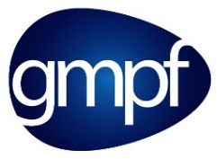

Are you keeping up to date with your GMPF pension?
As an employee at **** you will have automatically started to contribute to your pension at Greater Manchester Pension Fund (GMPF) when you joined. You may have opted out of your pension since then, but you can opt back in at any time.
GMPF is one of 88 regional Local Government Pension Schemes (LGPS) funds across England and Wales and the benefits you receive are set out in the rules of the Scheme. You can find out more about how your benefits are calculated at www.gmpf.org.uk/members/joining/calculating-benefits.
As a member of GMPF, you have access to a personalised online My Pension account. My Pension is there to help you access information about your pension at any time. Once registered for My Pension you will be able to:
- keep up to date with your pension
- use the online calculators to estimate the value of your benefits from age 55 onwards
- view and update your personal and contact details
- view and change your death lump sum nomination details
- view correspondence such as your annual benefit statements
- securely upload certain forms and documents meaning you don’t need to print or post them.
If you have not yet registered to My Pension you can do so today at https://mypension.gmpf.org.uk/.
If you need any help or have any questions, GMPF is there to help. You can contact their Customer Services team on 0161 301 7000 or complete one of their online forms on the GMPF website.

